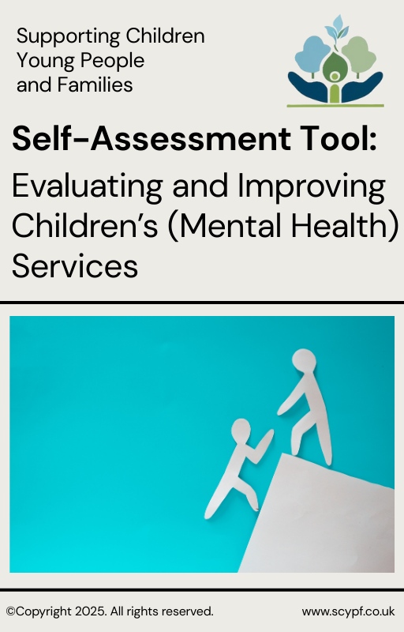

**Evaluating and Improving   
Children & Young People’s Mental Health Services:   
a Self-Assessment Tool for System Leaders**

**Rate each statement below on a scale from 0 (strongly disagree)** to **10 (strongly agree)**.   
Use the examples to help guide your rating.

|  |  |  |  |
| --- | --- | --- | --- |
| **Self-Assessment Statements** | | | 0-10 |
| **Everyone knows where to go, who to contact, and how to access help if/when needed.** 0-3 (Poor) Confusion about how to access support; poor communication and strained relationships between teams/services.  8-10 (Excellent) Clear, consistent communication channels; everyone is well-informed about where to go and how to get help. | | | Rating |
| **Children and young people can access services in a timely manner.**  0-3: Long or unknown or hidden waiting lists; urgent cases struggle to get immediate help. Clinical harm regularly occurring. 8-10: Outperforming waiting time standards. Routine support within 4 weeks; urgent cases always supported within timeframes. | | | Rating |
| **Children and young people receive the right level of support based on their needs.** 0-3: Over-reliance on specialist services, lack of early intervention, young people ‘bounce’ between teams/services/pathways. 8-10: Well-balanced services, no ‘bottlenecks’; with clear pathways and integration from early help to specialist care. | | | Rating |
| **Children, young people, and families remain engaged throughout their care journey.** 0-3: High drop-out rates/re-referrals, families and professionals report children and families feel unheard and unsupported. 8-10: High retention rate, and completion rate, evidenced through ROMs, low re-referral rates, high satisfaction and feedback. | | | Rating |
| **Young people and families are actively involved in decisions about their care.** 0-3: Families feel excluded from decisions; not offered choice; feel ‘done to’, unheard, unsupported. 8-10: Shared decision making, personalised care plans, young people and families involved in/chair MDT/multi-agency meetings. | | | Rating |
| **Children and young people achieve the goals they set in treatment.** 0-3: Young People’s needs are not met, high re-referral rates (or dissatisfaction in feedback), high incidents of clinical harm. 8-10: Young People meet and exceed therapy goals, high numbers of young people avoid, and/or return from, inpatient care. | | | Rating |
| **Services routinely monitor and use outcome measures (ROMs) and service feedback effectively.** 0-3: No collection of ROMs or feedback, frequent complaints, feedback not acted upon or communicated. 8-10: Strong satisfaction, ROMs and feedback drive service improvements and personal care plan adjustments. | | | Rating |
| **Services provide evidence-based interventions aligned with CYPIAPT and NICE guidelines.** 0-3: Incorrect or inconsistent use of evidence-base. Young People have limited or no access to evidence-based therapies. 8-10: All staff are trained to deliver, and have regular supervision and CPD for, delivering (NICE) recommended interventions. | | | Rating |
| **Staff receive training, supervision and CPD to support them establish and maintain CYPMH Competencies.** 0-3: Competencies not known/Staff feel unsupported and lack key skills and understanding. 8-10: Competencies exceeded and regularly reviewed. Consistent & high-quality supervision, training and induction for new staff. | | | Rating |
| **Staff vacancies are filled in a timely manner to ensure service continuity.** 0-3: Persistent staffing gaps lead to long waiting lists and frequently cancelled/rearranged appointments or increasing threshold. 8-10: Proactive and planned recruitment; minimal disruption to service delivery; effective use of finances (i.e no agency spend). | | | Rating |
| **Staff retention is strong, and wellbeing support is in place.** 0-3: High turnover; Burnout; Low Morale; High sickness absences relating to work 8-10: Staff feel valued, supported, know how to access support if needed, and access to support is high-quality and timely. | | | Rating |
| **Services are accessible and representative of the local population across all demographic groups.** 0-3: Certain groups (e.g., those from ethnic minorities, with additional needs, or from rural areas) struggle to access services. 8-10: Services accept self-referral and direct referrals. All groups aware of and access support and/or support is tailored to them. | | | Rating |
| **Services are well-integrated between health, education, social care, and community/voluntary sectors.** 0-3: Siloed working; no information sharing; duplication of, and gaps in, available support. Families do not know who does what. 8-10: Strong multi-agency collaboration and shared care planning. Shared information systems. Single referral for all support. | | | Rating |
| **Transitions between services are smooth and well-managed.** 0-3: Young People lost between services, or experience delays and drastic changes in their care without warning or preparation. 8-10: Seamless transition with clear planning, joined up (side by side) working, and continuity of care. | | | Rating |
| **What was your total score?** (maximum 140): | Click or tap here to enter text. |

**How Did You Arrive at Your Scores?**

|  |  |
| --- | --- |
| For each question, consider **what evidence or sources** influenced your rating.  In how many of the 14 questions did you use or consider: | **None, Some, Half, Most, All** |
| **High Quality, Accurate, Verified, Consistent Quantitative Data**  (waiting times, outcome measures, staffing stats, benchmarking data) | Rating |
| **Recent, Representative Service User Feedback**  (from children, young people, parents, carers, FFT or other surveys) | Rating |
| **Recent, Representative Staff Feedback**  (staff survey results, supervision, exit interviews, Freedom to Speak Up) | Rating |
| **Regular and Consistent Direct Experience**  (observations from presence in the service(s), professional judgment) | Rating |
| **Inspection or Audit Reports**  (CQC, Ofsted, Healthwatch, NHS Benchmarking, Serious Case/Incident Reviews) | Rating |
| **Other** (please specify): Click or tap here to enter text. | Rating |

**Confidence in Your Scores**   
On a scale of **0-10 (0 = No confidence, 10 = Absolute Confidence)**

|  |  |
| --- | --- |
| **How confident are you that your ratings accurately reflect your services?** 0-3 (Low): Based mainly on gut feeling or limited feedback, and/or from outdated or low quality sources. 4-6 (Moderate): Some data or mixed sources, but gaps remain. 7-10 (High): Strong evidence base from multiple sources, that is known to be current, consistent and high quality. | Rating |

**Generate your overall score:** (Maximum 1400)

|  |  |  |
| --- | --- | --- |
| **Your total score** [out of 140] **X** **Your confidence score** [0-10] **=** | | Click or tap here to enter text. |
| Reflect on your key strengths (which were your highest scores, how do you achieve and maintain them): | Click or tap here to enter text. | |
| What are your priority areas for improvement or attention (lowest scoring areas, or an area that most worried you as you scored it): | Click or tap here to enter text. | |

**For more resources, or information about available support and training please visit:** [**www.scypf.co.uk**](http://www.scypf.co.uk)